IMECS 2011
Year
8
16-18 March 2011, Hong Kong, China
Amateur Radio:
More than a hobby!
TUTORIAL
Amateur Radio in Education
© Miroslav Skoric
Faculty of Technical Sciences • University of Novi Sad
skoric@uns.ac.rs • http://tldp.org/howto/FBB.html

Table of Contents
Chapter 1
Introduction 1
Chapter 2
Problem Definition 3
What the Amateur Radio can do? 4
Chapter 3
'Packet-radio' connections 5
Amateur Radio Relays 6
Advantages of the Amateur 'Packet-radio' 7
Digital Networks 8
Chapter 4
'Packet-radio' experiments 9
1st Scenario 9
2nd Scenario 10
3rd Scenario 10
4th Scenario 11
5th Scenario 13
Chapter 5
Summer schools on the amateur radio computing 14
Expand your knowledge 15
Test your knowledge 16

Introduction
Chapter
1
How I started with amateur radio. How we all started. How could you start?
the amateur radio is an old fine hobby from the days of inventing the Morse alphabet and implementing telegraphy. Since the second half of the 19th century, millions of volunteers learned new skills in communications – while attending the amateur radio courses and successfully passed examinations; got their first radio licenses and started transmitting signals to the spectrum.
The electronics industry recognized the incoming 'flood' of the new communicating enthusiasts, coming from all over the world and predicted them to be a good market very soon. Today we have many opportunities to purchase sophisticated and computerized amateur radio 'gadgets' – that include fascinating traditional and brand new communication modes. Besides telegraphy and radiotelephony, there are varieties of computer-related possibilities to explore. As a result, today the modern radio amateurs are capable to establish exciting radio paths via Moon or artificial satellites, conducting short discussions with crews on the space ships, even to make an urgent search for medicines – by using their computers.
My first contact with the amateur radio was in early eighties when I signed for a radio course. In those days, there were no personal computers available so I had to take a manual Morse alphabet school. I must admit, I have not learned more than few telegraphy characters and soon after – I gave up. Then appeared a long period of time when I did not make much effort to re-join the amateur radio community. I had to finish with my early school days and make an important decision about profession for which I would like to continue to educate. You bet, I quickly found an answer and it was the electrical school. I knew that there would be lots of various instruments, electronics circuits, antennas, early pocket calculators and other interesting stuff. After some years, I became a qualified electrician – likely to learn more and explore new worlds of technology. Then it was the time to pick a university and the best bet was to sign with the electrical engineering one. Well, you know, those days I preferred music and dating with young ladies – rather than to visit department's physics lab – so I switched to a business computing faculty. I graduated with over-an-average marks, as an informatics system designer.
However, at the time of getting my first engineering degree, I was deeply involved in local amateur radioactivities. In fact, during my undergraduate education, I got in touch with computer systems and I knew I would handle them through the rest of my career. Somehow, the first "Commodore 64" computer found a place in the local 'ham' (ham is the amateur radio) club and my friends and me made a wired link to the radio station. After the years of speaking to microphones, it was exciting to establish our very first keyboard-to-keyboard chat. You know, during the late eighties, in this area almost nobody knew of things like the Internet e-mail, messages via cell telephones etc. Besides chatting we were capable to exchange text and binary (program) files. Moreover, we did that at almost no cost, because we only used our radio transmitters! I mean, there were no ISP services included; neither was we given bills for communicating over the fixed or mobile infrastructure. Having an opportunity to move the club's technical equipment to the local school, we got a chance to motivate the students to join us. Soon after, a bunch of school kids became the regular club's visitors and participants of the amateur radio course we offered. The same or similar history many ham groups can tell. That is why we want to motivate educational institutions to join the global amateur radio family. This hobby gives various opportunities for all – some of them are very affordable solution for remote schools in rural areas or developing countries. The tutorial you participate to is going to provide instructions on how to start with the amateur radio and how to use both radio and computer technology for the same purpose.
To save you enough time for questions and discussion at the end of the tutorial session, in this 'handout' we provide detailed descriptions of some key slides, for your convenience.

icon key
- Valuable information
 Test your knowledge
 Email communication
- Keyboard exercise
- Workbook review
In addition, we provide several references in print and web pointers that will help you to find more sources of information and study the topic on your own.
We hope that you are going to get motivated for joining the amateur radio community. The amateur radio offers a lot of fun for all those who want to learn more about engineering and technology. Should you want to join us, do not hesitate to ask for information related to the local radio clubs, societies and larger unions. The best way is to find an amateur radio individual, who lives in your neighborhood. Such a person is capable to give you basic information about what you can expect after passing your initial amateur radio examination and obtaining your radio emission license. With your certificate in hands, you are allowed to establish your first radio transmission from your friends' or clubs' equipment. The next step is to look for appropriate hardware and software to start on your own. In this tutorial, we will learn about the ways to save money and to begin with your digital experience without so many finances.
Problem definition
Chapter
2
Engineering education issues and perspectives.
Since the start of new millennium, we face to a decreasing interest in studying electrical engineering and computer science in many nations:
Figure 2.1 Such discouraging titles we can see in many newspapers today as well as in various reports on the actual state in academic education and student enrolments in latest years.
It is obvious that the situation is much worrying in developed than in developing countries (EU, USA, Japan etcetera – versus India, China, Eastern Europe etc). Unfortunately, the problem gets worse for developing countries because of the well-known phenomenon called "brain-drain".
Many educational foundations, international engineering societies and similar entities have already noticed the problem and have been trying to offer reliable solutions. The idea is to reverse negative trends into something like this:
Figure 2.2 The question is if we can and how to change actual trends into something like that. Amateur radio is one of the existing ways to build up the base of technically skilled people in a community.

What the Amateur Radio can do?
First, you can learn the basic radio skills at your very early age: The radio amateurs have exciting experience with establishing voice and digital communications between pupils in the primary schools and astronauts. Next, you can learn how to build and install radio stations, antennas, grounding facilities and other equipment – for both home and work purpose. The amateur radio could easily become an additional task for your technical classes and experimental laboratories. Further interchange of new knowledge is also a fun for youngsters, regardless where they live and what communal comfort they have in their surroundings and every day's life. 'Ham' radio contributes to improving technological literacy in a society because it attracts various professions, like doctors, lawyers, artists, soldiers, academics and others. Despite its enthusiastic and hobbyist nature, the amateur radio communications are legal and well-regulated activities (sometimes too much regulated!).
You can find radio amateurs everywhere: They mostly live in urban city zones, but sometimes you could find them at remote locations or rural areas, which are unequipped with commercial communication lines. Radio amateurs gather in local clubs, national and regional unions. There are several millions of active 'hams' worldwide.
'Packet-radio' connections
Chapter
3
The simplest way of interconnecting two (or more) computers – by using the amateur radio infrastructure and avoiding any commercial service you have to pay for, is to supply a pair of modems and small 'walkie-talkie' radios:
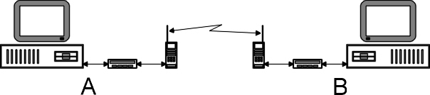
Figure 3.1 Both correspondents (A and B) have to use special modems for transforming their computers' digital signals into analog (voice) signals, capable to be transmitted over radio waves.
You do not need to invest into expensive equipment because older versions of computers will satisfy basic communicating needs:
This PC 'client' machine is equipped with CPU Intel 80286 at 12 MHz, 1 MB of RAM, 40 MB hard disk drive and black/white monitor.
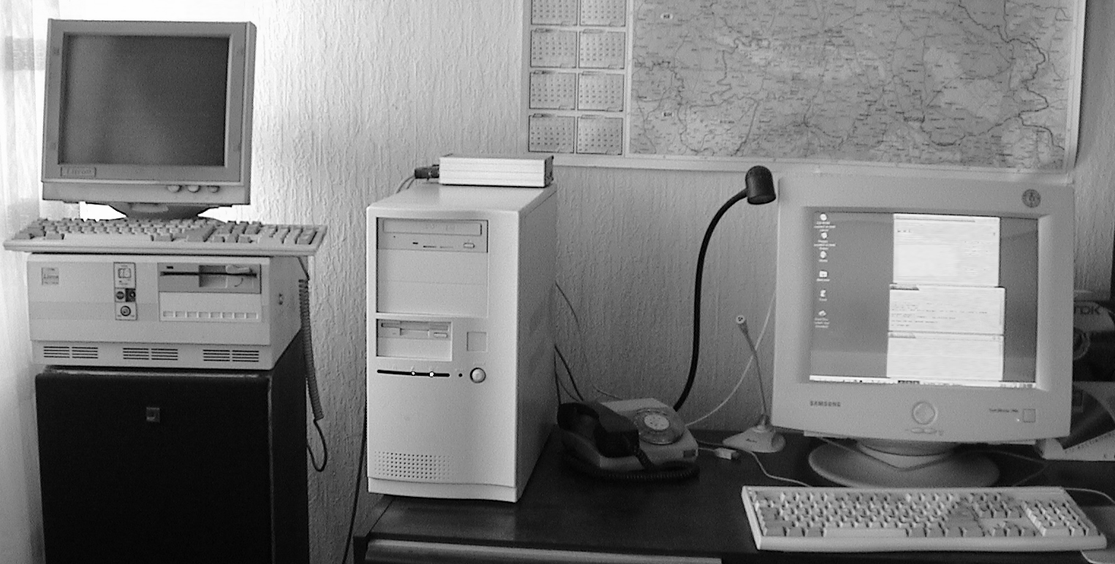
This PC 'server' is equipped with an Intel Celeron II at 400 MHz, 224 MB of RAM, 8 GB hard disk drive and color display.
Figure 3.2 A small local area network for experimenting with various amateur radio solutions. It uses less than average computers and radio equipment that truly satisfy all basic experimenters' requirements (MS DOS, MS Windows™ and Linux).
Furthermore, it is possible to use either of computers from Fig. 3.2 to run a 'Bulletin board system" ("BBS"), like in Fig. 3.3:
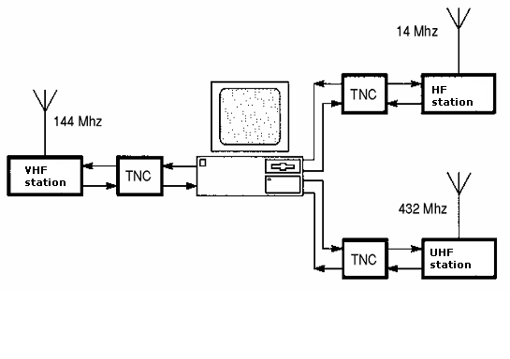
VHF amateur radio station with an antenna for frequencies around 144 MHz ('2-meter' band) for local coverage.
TNC (= Terminal Node Controller) is a generic name for modems dedicated for amateur radio use. TNC's can work as personal mailboxes.
HF amateur radio station with an antenna for frequencies around 14 MHz ('20-meter' band) for international traffic.
UHF amateur radio station with an antenna for frequencies around 432 MHz ('70-cm' band) for inter-node links.
E-mail server
(BBS)
Figure 3.3 Individual 'hams' and clubs who prefer more complex amateur experiments can construct systems of several radio stations for different purpose and extended user capabilities.
Fig. 3.3 describes a 'BBS' facility equipped with three radio stations – each one for separate coverage. So-called 2-meter band we mainly use for domestic connections within 1-20 kilometer circle; 20-meter band is of primary interest for the intercontinental traffic and 70-centimeter band is intended for automatic connections between radio-relay systems (repeaters). Many amateurs mix all those functions, so it is common to find relays on 144MHz, as well as to establish chat conversations on 432 MHz and up.

Amateur Radio Relays
Very often, it is not possible to obtain an 'optical visibility' between two neighboring packet-radio stations (correspondents). In such cases, the radio amateurs install special relay stations whose task is to receive signals, to amplify them and re-transmit. With the help of those relays, the end-users do not need to invest in their own amplifiers and to waste more electricity to reach their distant correspondents. Whenever possible, we put our relay stations at high altitudes – most commonly on top of nearest mountains or high buildings. That way, it is possible to avoid various natural or artificial obstacles that prevent direct links between two users:
In this example, we can see two remote radio amateurs, YU7A and YU1A, who are located at the opposite sides of a mountain. They cannot 'see' each other because of this natural object. Fortunately, the amateur relay station 4N7ZNS provides the indirect connection between two end-users. Both users traffic their signals with the relay and the relay serves the two 'customers' automatically. With using a relay station (a 'digipeater' = digital repeater), it takes a little bit more time to reach the corresponding station and that time is multiplied if more than one relay is in use.
In addition, on the shorter path between YU7A and YU7B (say, in the same but large city area), the relay 4N7ZNS provides an indirect connection after an existing direct link becomes unreliable (Eg. after building a new skyscraper in the city, or something similar).
Figure 3.4 Amateur radio repeaters ('digipeaters') often save the day when direct links between correspondents are not possible or become unreliable for any reason. If possible, an educational institution can install a local repeater on its own – in order to expand its end-user station (or a BBS) coverage.

Advantages of the Amateur 'Packet-radio'
The independence from commercial communication service providers brings many advantages to the radio amateurs: First, there are no expenses for communication itself. That means a 1 minute costs the same as 1 hour or 1 day of having a link with another station! The amateur 'packet-radio' is a mobile and an ad-hoc communicating system, because you can install the radio station and modem it in your vehicle and park it at the nearest hilltop temporarily (say, for a few hours or a weekend, or similar). In the mean time, all active amateurs living around the hill can use it as a relaying system. Such way of communication we can use as an exercise of emergency links in case of natural disasters, winter storms etc. If we add a portable computer (laptop) to our moving relay station, then it is possible to run an email server (BBS) from our temporary location. The whole system is low power consuming and it could be equipped with another set of rechargeable batteries.
Besides its real-time communicating capability and e-mail features, the amateur digital radio offers full text and binary file exchange, which means that you can send and receive small computer programs, pictures, databases and similar things. Be aware, though, that legal regulations prohibit any traffic of commercial or otherwise proprietary materials. In the same time, I would encourage pupils, students and their teachers to use it at school excursions or eventual scientific expeditions or so. Having in mind that the rules permit discussions that are close to research, studying or teaching electronics, mathematics, computing and similar parts of science, the scholars can practice with 'ham' radio in practically unlimited manner.

Digital Networks
One of the frequently asked questions is the "data speed". Frankly speaking, the amateur radio is not going to compete in speed with the Internet and telephony providers and it never did so. That means the data throughput of an average packet-radio route is much narrower, i.e. slower than any kind of nowadays-commercial data systems. However, who cares about? In fact, we do not need to worry about increasing bills – so we do not need to finish our connections as soon as possible. In addition, most of the amateur radio links depend on the atmospheric conditions and general characteristics of some radio frequency portions:
Some VHF and most UHF packet-radio transmitters can achieve high-speed rates. A drawback is that you cannot use the majority of high-speed radios for anything else but digital operations.
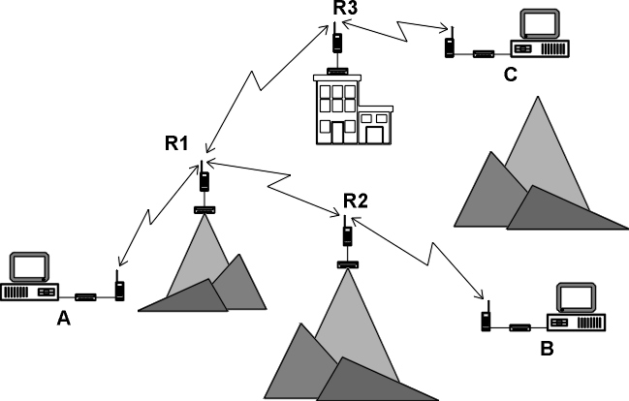
300 / 1200 bps
1.2 Mbps
…
38.4 Kbps
19.2 Kbps
9600 bps
1200 bps
Most VHF systems experience 1200 bps (bit per second) only.

Most HF systems work at 300 bps only.

However, you can use the same radios for not only packet-radio but for VHF/HF voice operations, amateur telegraphy, teletype, amateur TV etc.
Figure 3.5 An ultimate speed of data traffic you could achieve depends on the funds you want to invest in your system, as well as to a diversity of communication modes you are likely to experiment with. It is possibly to modify electrical circuits in some radios to get more speed, but many modifications are irreversible and remove some of the original features of your radio.
It is not hard to imagine what we can do with the amateur 'packet-radio' as a learning technology. Look at the Fig. 3.5 again: Let us suppose that we have installed the repeater R3 on top of a high building within our university campus. If we connect by a cable that R3 to a local area network, which we already have in our academic environment, it will be possible to 'gateway' from a LAN to the amateur radio spectrum! That means, our students will be able to communicate with radio amateurs who live in the area – including friends and parents (if they are also 'hams').
Furthermore, if "our" repeater R3 has a reliable connectivity with relays R1 and R2, then it will be possible for distant users A and B to establish conversations with us at the location C ("us" is some of us, the system administrators of R3, who live close to the location of R3).
'Packet-radio' experiments
Chapter
4
Scenarios for tests in educational institutions: You have a diverse variety of options to play with hardware and software.

1st Scenario
The 'sysop' (the system administrator) is the single user. There is no LAN yet::
MS DOS “DosFBB” server application
Windows “WinFBB” server application
Linux “LinFBB” server application (X11)
Linux “LinFBB” server daemon (“xfbbd”)
This is the simplest situation where the central part of the game is the bulletin board system's operator keyboard (a 'console'). Practically, nobody but the system operator is involved in using that system. Something like that is suitable for software test beds and isolated areas with no radio users.

The BBS software is one of the most popular amateur radio programs, FBB, which comes in various flavors for most operating systems.

- www.f6fbb.org
Figure 4.1 The 'sysop' of this server is the single user of his / her bulletin board system.
The situation described in Fig. 4.1 is a beginner's best approach. The idea is to install the bulletin board program and get some basic clues about its functionality. An educator can use his / her own computer to try the software in the 'test' mode (without modems attached).

2nd Scenario
The 'sysop' is still the only user (there is no LAN yet):
Linux “LinFBB” server daemon (“xfbbd”)
Linux “xfbbC” local client (text mode)
Linux “telnet” command (server console)
Linux “xfbbX” local client (GUI mode)
This is an extension of the previous situation (1st scenario). The central part of the game is still the system operator's 'console'. The requirement is that the BBS operates under Linux, which provides various (internal) networking capabilities.

Something like that is suitable for network simulations and isolated areas with no local users.

The BBS software is LinFBB, the Linux version of the popular amateur radio program, FBB.

- www.f6fbb.org

Figure 4.2 The 'sysop' is yet the single user of the bulletin board, but with extended network test options. This is an advanced learning step for a BBS system administrator who experiment with intricacies of Linux networking and explore both text and graphical environments in that operating system. The 'sysop' can practice how to add or remove privileges to his /her future users.

3rd Scenario
Now the local user access from the LAN is (finally) possible. The 'sysop' is responsible for proper maintaining of user permissions given to his / her customers – students, teachers and others who use the LAN.
One should take care of the correct assigning the end-user privileges, in order to avoid writing messages by using inappropriate language or bad words, deleting something within the system etc. When it comes to assigning the proper user permissions, we suggest starting with a 'read-only' level and increase the user capabilities incrementally – according to the communicating skill acquired; eventual assigning co-sysops or so.
The end-user software in Fig. 4.3 comes at no additional costs because it is either already included within the existing operating system (the 'telnet' command or its derivatives), or it is xfbbW – another free amateur radio software, as FBB is. Before starting with experiments, the users on the LAN should get some basic instructions, like using 'telnet' command and get elementary knowledge about the networking.
Windows “telnet” command (LAN user)
Windows “xfbbW” client (LAN sysop)
MS DOS “telnet” command (LAN user)
This scenario describes an extension of the previous situation. Now the users can access the e-mail server from within the local area network (LAN).

That option is suitable for extensive testing the school's local area network, as well as for the simulation of a remote access (without radio stations).

The BBS software is LinFBB, the Linux version of the free amateur radio program, FBB.

- www.f6fbb.org

Figure 4.3 The students and teachers can access their e-mail from within the LAN and simulate a radio access to the BBS. As described, the users with lower privileges will exercise their abilities to use 'telnet' command within their Windows™, DOS or even Linux working environments. The 'sysop' does not need to stay at the BBS console anymore: He / she is capable to control their users' activities after using the 'telnet' command, by running xfbbW at another computer in the LAN.

4th Scenario
That is an extension of the previous (3rd) scenario: Now the user access is possible by using the 'telnet' command – included within some external programs for DOS operating system. You could ask, Why to use DOS computers at all? The answer is simple: DOS has proven as a reliable OS, particularly for the older generations of PC computers that many of us still have in our closets. For the sake of our experiments, we will use an 'ancient' PC machine equipped with CPU Intel 80286, operating system MS DOS v. 5.0 and amateur radio software Xrouter and JNOS. When using DOS-based computers for the local area networking, you need to activate your network card drivers before you start your networking software like Xrouter or JNOS.
Both Xrouter and JNOS implement the 'telnet' command in a similar manner as the same command works elsewhere, so we could use it for accessing our bulletin board system that runs on the other, Linux-based computer. In addition, those of you who want to learn more about the variety of amateur radio features implemented within Xrouter and JNOS, can do that before or after your 'telnet' session. (Both Xrouter and JNOS we can use not only as 'client', i.e. end-user machines, but also as a kind of 'gateway' or 'server' computers for various amateur radio purposes.)
Nevertheless, once again the 'sysop' is responsible for giving user permissions to his or her customers.
This scenario describes an extension of the previous situation. Now the users can access their e-mail server from within the LAN, by running MS DOS computers equipped with Xrouter or JNOS software.

That option is suitable for various simulation of a remote access (without radio stations yet).

The main BBS software is LinFBB, the Linux version of the free amateur radio program, FBB.

- Before starting networking software in DOS, do not forget to run drivers for your NIC (network interface card).

MS DOS “Xrouter” telnet command
MS DOS “JNOS” telnet command
Figure 4.4 Students and teachers can access their e-mail within the LAN and simulate a radio access to the BBS.
The fourth scenario has involved our students and teachers into a variety of amateur radio programs: FBB, Xrouter and JNOS. All of them have something in common, but also have many differences and additional options to explore. For example, we might want to add packet-radio modems and radio stations to the end-user computers above (the boy on the left and the girl on the right). In that situation, we extend working capabilities of those users: If it were an Xrouter-based computer, it would be possible to explore complex routing of TCP/IP data packets on top of the AX.25 (= 'Amateur X.25, i.e. 'packet-radio') traffic. If it were a JNOS-based station, it would be possible to do the same, but with an added option of running a local (MS DOS) mailbox, a POP/SMTP server, a HTTP server etc. Now the final step is the …

5th Scenario
That is an extension of the previous, fourth scenario and now we are going to explore the usage of the 'telnet' command, but in the opposite direction. That means the user (that is the 'sysop' in this case) is going to access a JNOS-based computer that runs in the mailbox mode. To allow incoming telnet access to JNOS by using the local area network, the sysop has to maintain appropriate JNOS' user privileges, similarly to those of FBB mailbox program.
Depending on the quality of a particular DOS + JNOS computer, you can expect faster or slower responses from your JNOS mailbox, like getting the lists of available messages within the mailbox or so. One of the reasons for the slower response is that every particular user connection has to be checked at the beginning of the next approach – in order to inform the user about his / her last connection, list of available (but not yet read) bulletins etc. It is also expectable to get slower response along with building a pile of newer and newer messages, which come to the JNOS mailbox database.
Telnet to DOS “JNOS” mailbox from Windows
Telnet to DOS “JNOS” mailbox from Linux
This scenario describes an extension of the previous situation. Now the FBB 'sysop' (and other users in the LAN – if enabled and allowed) can reach their JNOS mailbox from within the LAN.

That option is suitable for further simulation of a remote access to a BBS (still without any radio station involved).

The BBS software is JNOS, the DOS version of the free amateur radio program, JNOS.

- http://www.langelaar.net/projects/jnos2/index.html

Figure 4.5 The students and teachers can access their e-mail within the LAN and explore other features of JNOS software.

Summer Schools on the Amateur Radio Computing
Chapter
5
A summer (or a winter) school – discussing on the amateur radio in SC [sic] education can take app. 7-10 days and might be run alone or to be included as an added value into an existing event of computer science education. The most proper timing is the summer and/or winter vacation period of the school year. A call for participation would be addressed to a broad educational community, including master and doctoral students from Europe or elsewhere (A regional-wide approach would cut traveling and organizational costs.) With careful planning and preparing, such activity could not only accommodate theoretical lectures and practical demonstrations within the school labs, but to include social, cultural and recreational activities for students. Organizing institutions, preferably from the Mediterranean seaside in Europe (or any other destination), could host the sessions in the university’s premises and provide meals and accommodation within the student dormitories. The prospective candidates should cover their own travel costs to the venue.
The main part of that training would be to teach students and scholars to design, construct, program and use the local AMUNET, a grid of dedicated computers located at university campuses and surrounding schools, interconnected by the amateur radio infrastructure. Participants would learn about the most suitable hardware (computers, modems, radios, antennas, power supply etc) and software (server, client and repeater programs) for implementations at home, school or work. We are going to overview possible implementations of amateur radio in rural regions and developing communities: Students will get basic knowledge about the amateur radio satellites and exchanging e-mails without Internet connections and telephone lines, but still have optional and operational gateways between the 'ham' (amateur) radio infrastructure and the Internet. In order to motivate programmers to maintain the open source software products for the amateur computer communications and digital relay systems, as well as experimenters to document their own results, we would discuss (with examples) about writing operating manuals and various online documents.
We plan to activate the knowledge and equipment of the local radio amateurs and educational charities and perform practical demonstrations. Eventual co-sponsorships we expect from the scientific societies: IEEE, ACM, WSEAS, EESTEC; EU funds and other sources.

Expand your knowledge
Blystone, K., & Watson, M. (1995). Alternative Information Highways: Networking School BBSs. Denton, USA: Texas Center for Educational Technology

Diggens, M. (1990). Enhancing distance education through radio-computer communication. In R. Atkinson and C. McBeath (Eds.), Open Learning and New Technology: Conference proceedings, (pp. 113-116). Perth: Australian Society for Educational Technology

Ford, S (1995). Your Packet Companion. Newington, USA: American Radio Relay League

Hill, J. (2002). Amateur Radio—A Powerful Voice in Education. QST, 86(12), 52-54.

Hudspeth, D., & Plumlee, R. C. (1994). BBS Uses in Education. Denton, USA: Texas Center for Educational Technology

Lucas, L. (1997). Wide Area Networking Guide for Texas School Districts. Denton, USA: Texas Center for Educational Technology

Lucas, L. W., Jones J. G., & Moore D. L. (1992). Packet Radio: An Educator’s Alternative to Costly Telecommunications. Denton, USA: Texas Center for Educational Technology

McLarnon, B. (2008). Packet Radio Technology: An Overview. Retrieved June 25, 2008, from http://www.friends-partners.org/glosas/Tampere_Conference/Reference_Materials/Packet_Radio_Technology.html

Skoric, M. (2004). The Amateur Radio as a Learning Technology in Developing Contries. In Proceedings of the 4th IEEE International Conference on Advanced Learning Technologies (pp. 1029-1033). Los Alamitos, CA USA: IEEE Computer Society

Skoric, M. (2005). The perspectives of the Amateur University Networks – AMUNETs. WSEAS Transactions on Communications, 4, 834-845.

Skoric, M. (2006). The New Amateur Radio University Network – AMUNET (Part 2). In Proceedings of the 10th WSEAS International Conference on Computers (pp. 45-50). Athens, Greece: World Scientific and Engineering Academy and Society

Skoric, M. (2007). Bringing New Life in Old Computers. In Proceedings of the 26th ARRL and TAPR Digital Communications Conference (pp. 121-130). Newington, CT USA: American Radio Relay League

Skoric, M. (2008). The New Amateur Radio University Network – AMUNET (Part 3). In Proceedings of the 12th WSEAS International Conference on Computers: New Aspects of Computers (pp. 432-439). Athens, Greece: World Scientific and Engineering Academy and Society

Skoric, M. (2009). Amateur Radio in Education. In Handbook of Research on Human Performance and Instructional Technology (Eds. Song H., Kidd T.). Hershey, PA USA: IGI Global

Skoric, M. (2000-2009). FBB Packet-radio BBS mini-HOWTO. The Linux Documentation Project. Retrieved December 5, 2009, from http://tldp.org/HOWTO/FBB.html

Test your knowledge

homework
 Review this workbook
- Read suggested literature
 Put  in the proper box
1. What describes tasks and principles of 'ham radio':  Slide 1.4 and Slide 1.1  Figure 4.4 and Slide 1.1  Slide 1.1
2. What describes main characteristics of the amateur 'packet radio': Figure 3.3 Figure 4.4 Slide 1.6
3. What lists programs we used in our tests:  Figure 3.4  Slide 1.8  Slide 1.3
4. What describes requirements for the new license:  Slide 1.2  Slide 1.2 and Slide 1.5  Slide 1.5
5. What describes LinFBB's operating manual location on the Internet:  Figure 4.2 and Slide 1.8  Figure 4.2  Slide 1.8
6. What describes a TNC:  Figure 3.3 and Slide 1.7  Figure 3.4  Figure 3.4 and Figure 3.5
7. What describes 'digipeaters':  Figure 3.4 and Slide 1.7  Figure 3.3 and Slide 1.7
8. What describes computers we used in our tests:  Figure 3.2  Figure 3.4  Slide 1.1
9. What describes the educational issue(s) we want to solve:  Figure 3.4, Figure 4.5 and Slide 1.1  only Slide 1.1  Figure 2.1 and Figure 2.2
10. What describes portions of the amateur radio frequency spectrum:  Figure 3.4, Figure 4.4 and Slide 1.5  Figure 3.3 and Figure 3.5  Slide 1.2 and Slide 1.5

Slide 1.1 Slide 1.2

Slide 1.3 Slide 1.4
Slide 1.5 Slide 1.6
Slide 1.7 Slide 1.8

Thank you for participating in this tutorial!

feedback
 Check http://tldp.org/HOWTO/FBB.html
 Send email to skoric@uns.ac.rs

Copyright is held by the author/owner(s). ITiCSE ’07, June 23-27, 2007, Dundee, Scotland, United Kingdom. ACM 978-1-59593-610-3/07/0006.

