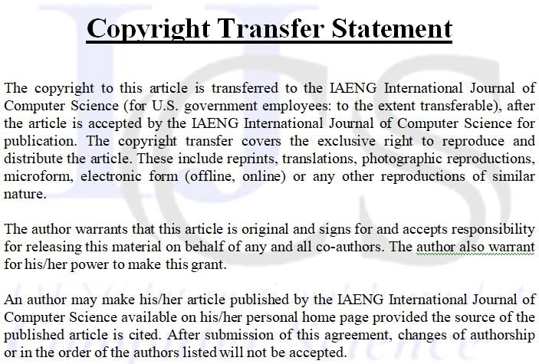

Title of Journal:

IAENG International Journal of Computer Science

Title of article:

Author(s):

Author’s signature:

Date:

